Student’s Name: Sierra Boyd and Jeremy Hansen  
  
Project’s Name: Nature’s Notebook

Project Start Date: 02/01/2025 Project End Date: 03/02/2025  
  
**Instructions**

During the first week, you will add two to three project goals that you are to accomplish by the end of **each week**. Then each week, you will use this document to continue to describe, in 2-3 sentences, the requirements that you completed, list any barriers to accomplishing any of your goals, and describe any additional assistance you will need from your instructor or other resource.

**Week One**

**Project goals to be completed in week 1:**

* 1. Plan Website Functionality
  2. Sort Out Project Responsibilities
  3. Create Workflow and UML Diagram
  4. Create Project Requirements Sheet
  5. Link GitHub Registry

**Description of project goals completed during week 1:**

Sierra and Jeremy will conduct our first meeting on creating the Nature’s Notebook website. This week's priorities will focus on the project management for the software life cycle. Sierra will complete a description of the website’s responsibilities, requirements, and basic user activity. Jeremy will Create a workflow diagram, UML diagram, Gantt chart, and GitHub Registry. This will give us a blueprint of what is needed to create the website, allow us to collaborate on the code, and have a basic timeline for everything that needs to be accomplished.

**Barriers:**

All projects must be completed before moving on to week two.

**Requested assistance:**

No assistance is currently needed.

**Week Two**

**Github Phase-1 URL**

https://github.com/jdizzworld6/Natures_Notebook/tree/Phase1

**Project goals to be completed in week 2:**

1. Create Sketchup Designs For Webpage
2. Create a Database on UML Diagram
3. Create basic Functionality that Connects to database
4. Create Functionality that allows user operations and user CRUD operations
5. Create controllers to use data from database
6. Set up security user accounts
7. Have a Meeting to Reassess the Plan and Finish Assignment
8. Submit Assignment

**Description of project goals completed during week 2:**

**Barriers:**

Creating Sketchup Design for web pages needs to be accomplished before building the layout. We need one more SketchUp for all photos for users.

This is looking like a substantial project for completion in 2 weeks. We will focus on creating a user account for personal use and then add a friends user page if we have time.

Admin page will be created basic so we can focus on the creativity of the users pages.

**Requested assistance:**

No assistance is currently needed.

Wireframe designs

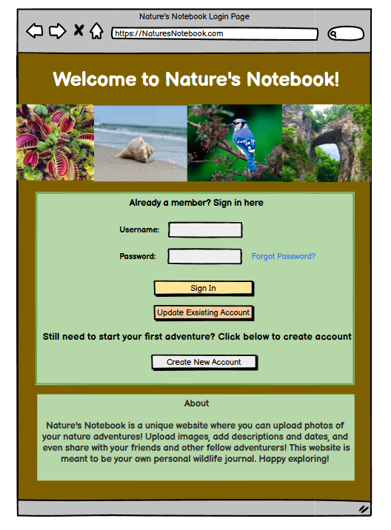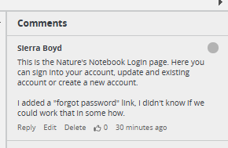

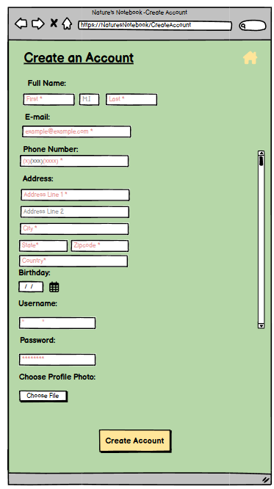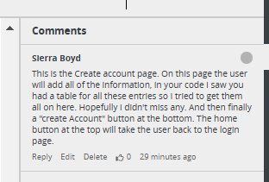

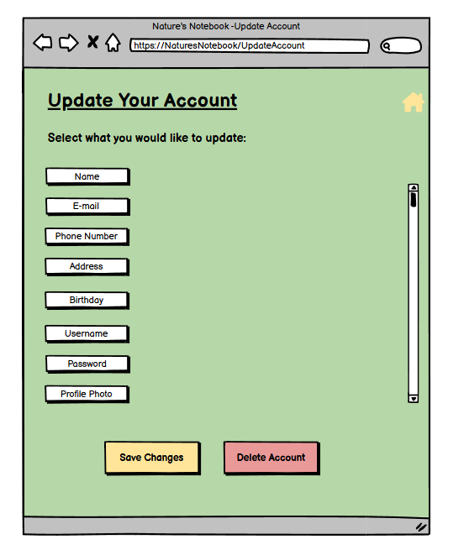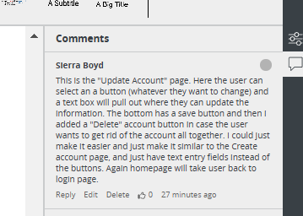

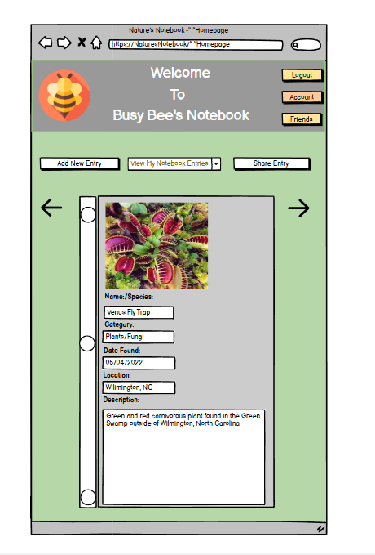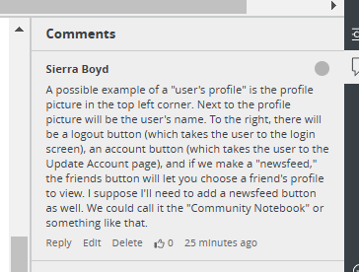

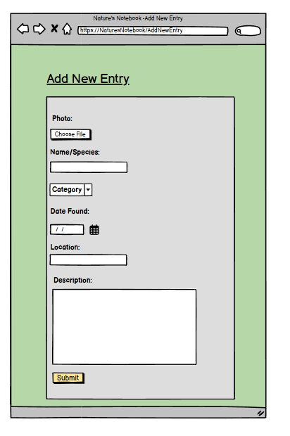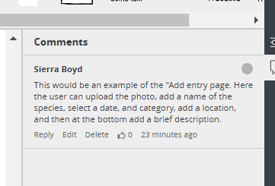

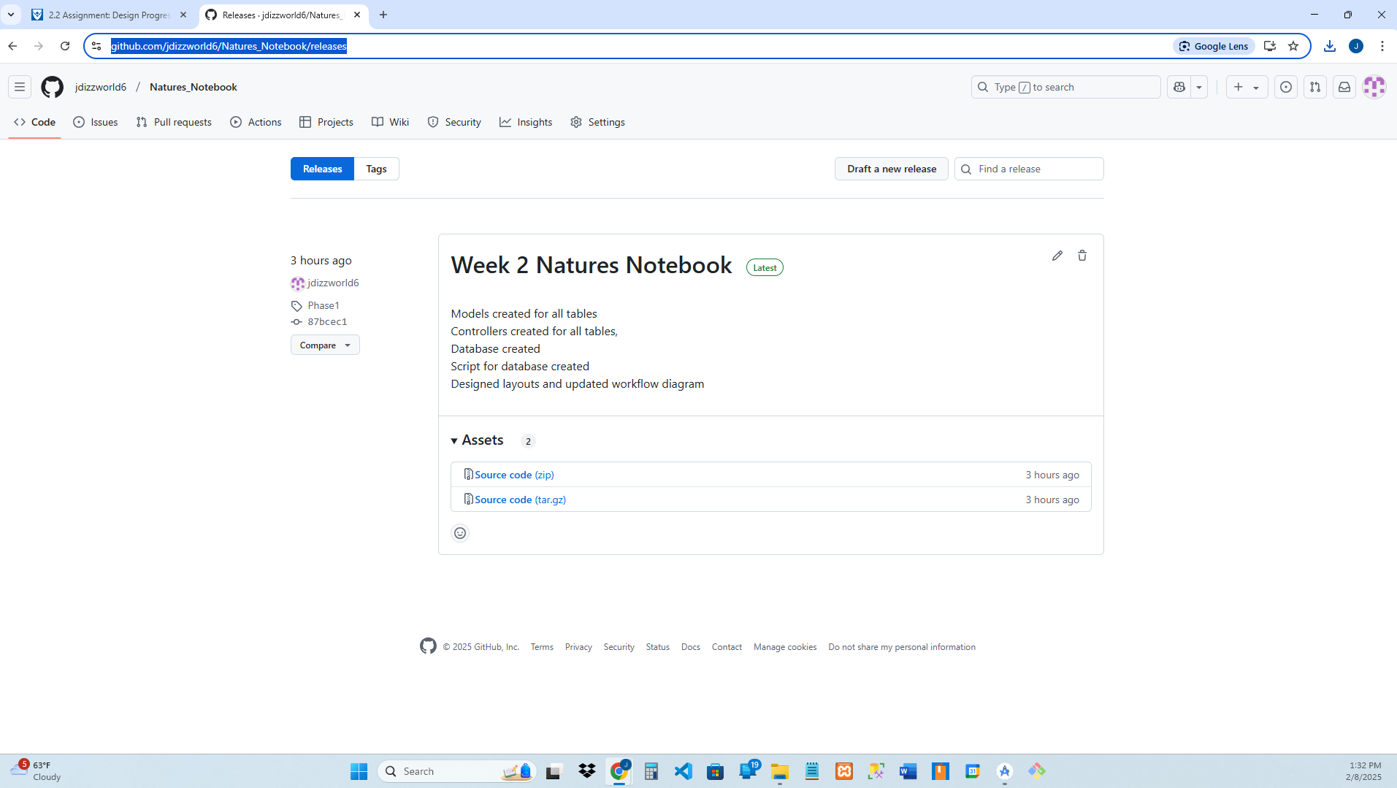

**Week Three**

**Github Phase-2 URL**

<https://github.com/jdizzworld6/Natures_Notebook/tree/jdizzworld6-phase-2>

**Project goals to be completed in week 3:**

1. Use CSS and Bootstrap to implement design
2. Continue functionality Focus on CRUD Operations
3. Continue functionality Focus on Search
4. Continue functionality Focus on Register
5. Have a Meeting to Reassess Plan and Finish Assignment
6. Submit Assignment

**Description of project goals completed during week 3:**

Sierra will be focusing on the front end design of the website using the UX designing principles. Jeremy will focus on the backend design, creating scripting code to connect the database to the front end.

Got completed

Sierra completed designs for Create an account, Homepage, and update a account. Jeremy finished all of the scripting on the Administrator workflow diagram. The scripting will be the same for the user accounts. I’ll have to decide whether to use general pages and then admin pages or separate them completely. Most likely I’ll create general pages to reduce the number of webpages and code needed. We are in a good position to finish the webpage next week.

**Barriers:**

We will have to use mock input boxes and buttons until the front end of the website is developed and then add the functionality to those items.

**Requested assistance:**

No assistance is currently needed.



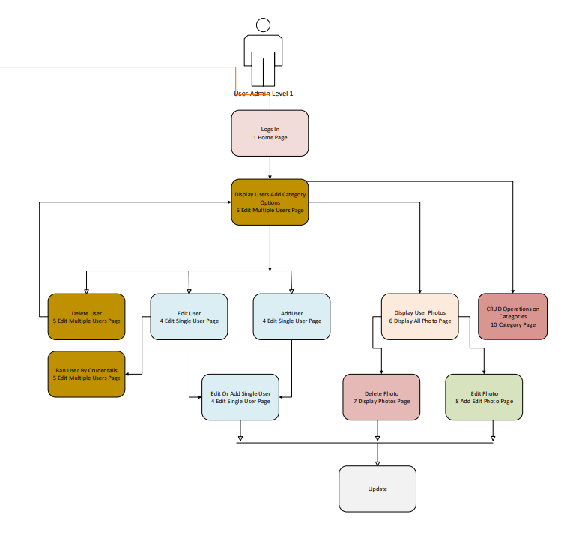

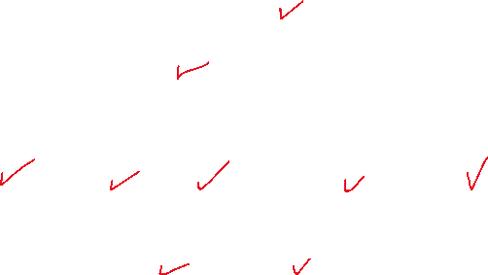

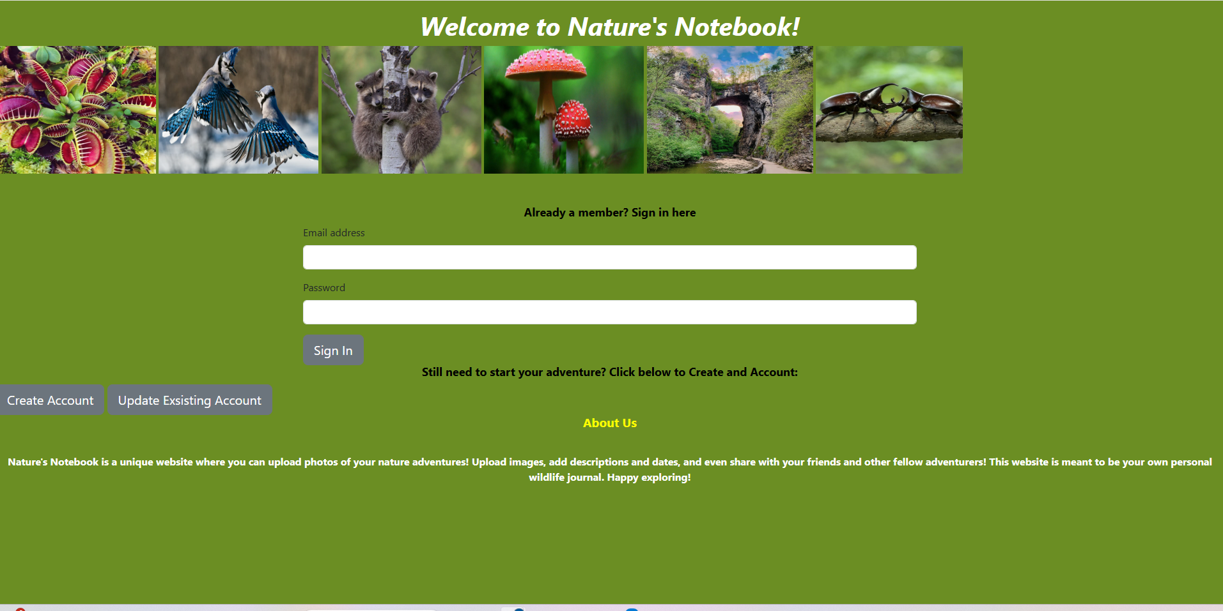

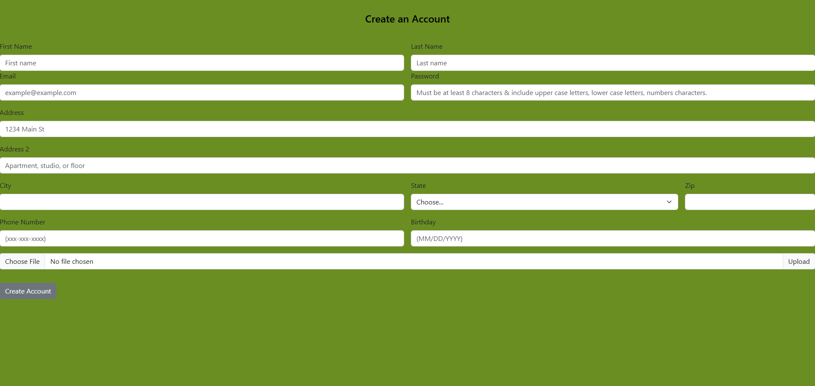

**Week 4**

**Github Phase-2 URL**

<https://github.com/jdizzworld6/Natures_Notebook/tree/Phase-3>

**Project goals to be completed in week 4:**

1. Finish up website
2. Test for functionality and different screen sizes
3. Finnish commenting code
4. Check for grammar and spelling errors
5. Make corrections based on feedback
6. Further test code for errors
7. Have a Meeting to Reassess Plan and Finish Assignment
8. Submit Assignment

**Description of project goals completed during week 4:**

We tested and finished the scripting for the website according to the workflow diagram. Sierra is still finishing the design, and we will implement it early next week for our presentation. Everything is going according to plan, and we will have a good social media-style website focused on nature photos.

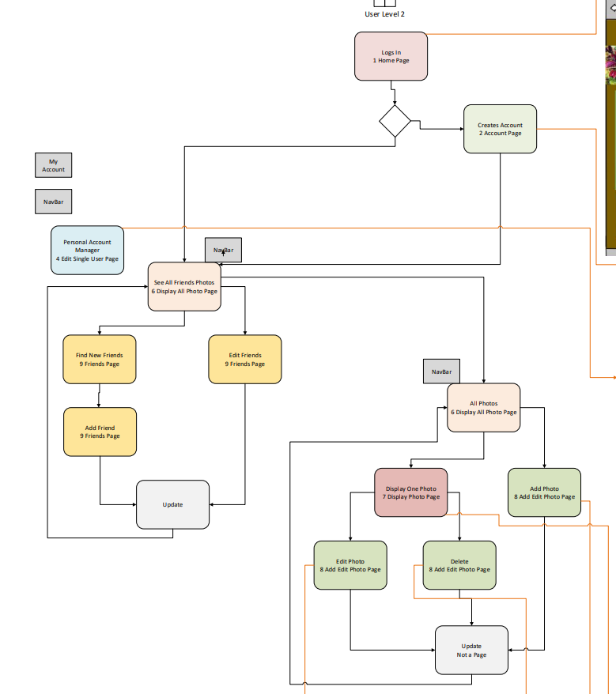



Create Delete on individual photo



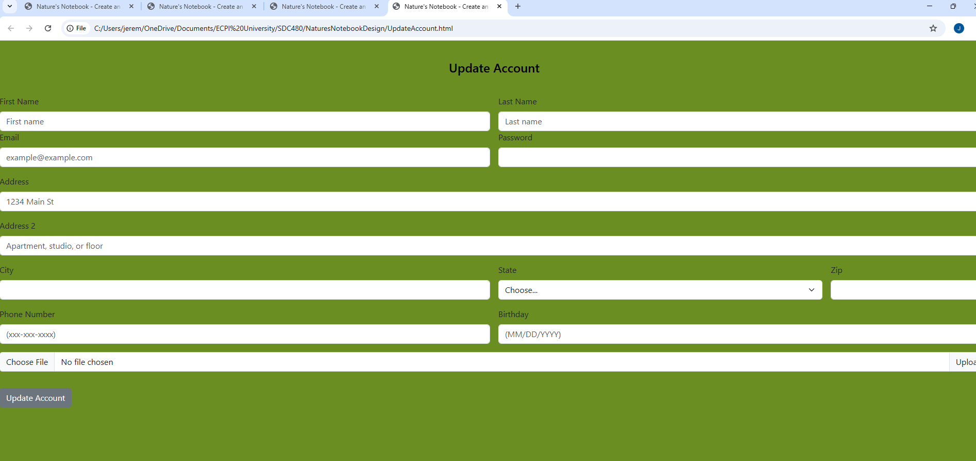

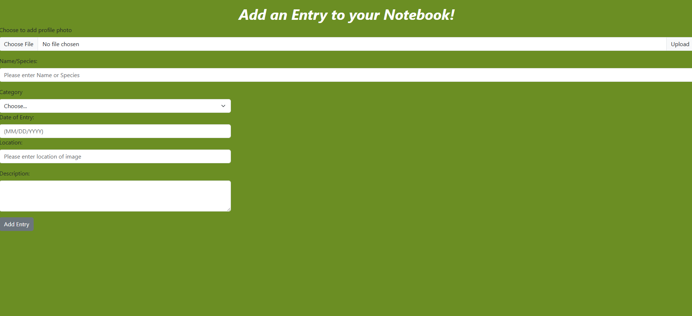

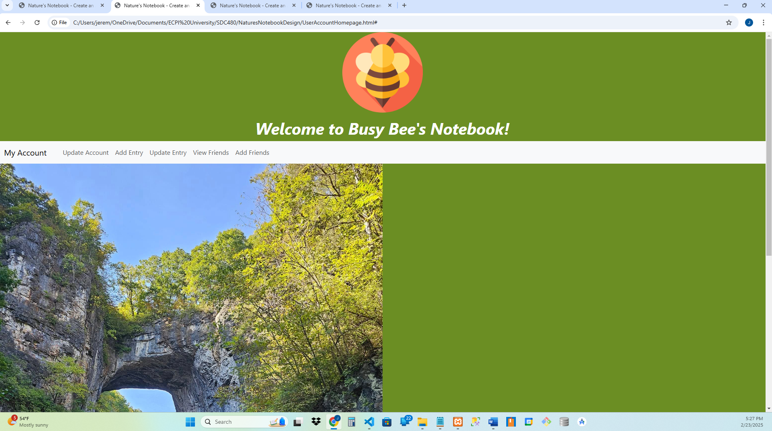

**Barriers:**

We need to finish the designs for the presentation.

**Requested assistance:**

No assistance is currently needed.

**Project Summary (e.g., what went well, what would you have improved upon)**

*Jeremy*

I’m inexperienced in coding a project this size and realize the pitfalls that can happen if you don’t structure the layout correctly. First, I attempted to use the same web pages for the admin and user levels. It quickly escalated to hundreds of lines of complicated logical code that was difficult to understand. After realizing this was an impractical method, I divided the web pages into user and administrator to keep things at a practical level. Even though I enjoy OOP programming, I found it best to limit the amount of data manipulation through OOP programming and manipulate the data through SQL statements. This allows a pass-through query to download and use only the necessary data. This prevents a slow-running website and allows complicated calculations to be handled on a server level. SQL statements are better designed for data manipulation. After finishing the website, I realized that the view folder had become overwhelming and would look better with another level of folders. This would have taken much time to reorganize and risk the website not running on week five. I’m also questioning whether my naming strategy could be better organized since I take too much time looking for files. Even though I’m sure it is a good practice, I wouldn’t use names such as “admin_level” and “user_level” when 1 and 2 could be used instead. I had moments when I named them backward and couldn’t figure out why I kept getting locked out of the website. Now, I’m overly reliant on the debugger, and hopefully, with experience, I can program in a way where I can narrow down the errors to resolve them quickly. I’m surprised that I got through the whole workflow diagram. I knew that at this level, it would be a risk. Still, I wanted to challenge myself and am glad I did because I learned an incredible amount by developing this website, and glad I did it as a partnership so I can focus on the functionality.

*Sierra*

**Week 4**

**Github Phase-2 URL**

<https://github.com/jdizzworld6/Natures_Notebook>

**Tags**

Natures_Notebook_Final

**Project goals to be completed in week 4:**

1. Finish adding Bootstrap grid system to user webpages
2. Create user accounts with the website
3. Created a JavaScript file that previews photos before uploading them
4. Fix website errors that come up when adding data
   1. SQL updates and add didn’t like “’” redesigned so string statement would have I am running a few minutes late; my previous meeting is running over. escapes
   2. Some button links wouldn’t work, forms and had to be reconstructed to anchor tags and made to look like buttons through CSS styling
   3. Some imports wouldn’t work because I used index folder level in the JASON file
5. Create a video on the website
6. Upload to GitHub changed the default to final and created a tag with Designing description.

**Description of project goals completed during week 5:**

Finished designing with CSS and Bootstrap grid system. Then, all seeded data was deleted, and user profile data was added to the webpage to ensure functionality. Fixed unforeseen bugs through the buildout. Created a video and uploaded it on YouTube of how the website works.

